**NAGAR NIGAM DEHRADUN**

**REQUEST FOR PROPOSAL (RFP)**

**For**

**Construction, Operation and**

**Maintenance of POLICE BOOTH & TRAFFIC Umbrella on**

**Build, Operate & Transfer Basis FOR DEHRADUN**

**(A  City)**

**Prepared By*:***



**Nagar Nigam, Dehradun**

**CONTENTS OF RFP DOCUMENT**

**The RFP document comprises the documents as listed below, and would additionally include any Addenda issued before the due date of submission of the RFP. Any reference to the RFP Document package includes all the contents unless specifically mentioned otherwise.**

**CONTENTS**

**Part A Instructions to Bidders**

**Part B Design, Appraisal and bid Submission Formats**

**Part C Draft Concession Agreement**



**Format Type – Design-Build-Operate-Transfer (DBOT)**

**Volume I – Instructions to Bidders (ITB)**

|  |  |
| --- | --- |
| **Date of release of Documents** | **31 December 2015** |
| **Presentation & Pre bid Meeting** | **11 January 2016 at 3.00 pm** |
| **Deadline for Submission** | **20 January 2016 by 2:00 pm** |
| **Opening of Technical Bid & Presentation** | **20 January 2016 from 3:00 p.m.** |
| **Opening of Financial Bid** | **The technically successful bidder shall be informed prior to the opening of financial bid through email or Call**  **financial** |
| **Venue** | **Nagar Nigam Dehradun** |
| **Issuing Office** | **Dehradun Nagar Nigam** |
| **Name and Designation of Issuing officer** | **Municipal Commissioner** |
| **Address of correspondence** | **Nagar Nigam, Dehradun** |
| **Phone no.** | **0135-2655620, 2653572,** |
| |  |  | | --- | --- | | **Email** | **nagar_nigam2008@yahoo.com** | | |  |  | | --- | --- | | **nagar_nigam2008@yahoo.com** |  | |

**This section specifies procedures to be followed by Bidders in preparation and submission of their Proposals and provides information on submission, opening, evaluation of Proposals and on award of concession.**

**DISCLAIMER**

**The information contained in this Request for Proposal document (the “RFP”) or Subsequently provided to Bidder(s), whether verbally or in documentary or any other form by or on behalf of the Nagar Nigam Dehradun or any of its employees or advisors, is provided to Bidder(s) on the terms and conditions set out in this RFP and such other terms and conditions subject to which such information is provided.**

**This RFP is not an agreement and is neither an offer nor invitation by the Nagar Nigam Dehradun to the prospective Bidders or any other person. The purpose of this RFP is to provide interested parties with information that may be useful to them in making their technical and financial offers (Bids) pursuant to this RFP. This RFP includes statements, which reflect various assumptions and assessments arrived at by the Nagar Nigam Dehradun in relation to the Project. Such assumptions, assessments and statements do not purport to contain all the information that each Bidder may require.**

**This RFP may not be appropriate for all persons, and it is not possible for the Nagar Nigam Dehradun, its employees or advisors to consider the investment objectives, financial situation and particular needs of each party who reads or uses this RFP. Each Bidder should, therefore, conduct its own investigations and analysis and should check the accuracy, adequacy, correctness, reliability and completeness of the assumptions, Assessments, statements and information contained in this RFP and obtain independent advice from appropriate sources. Information provided in this RFP to the Bidder(s) is on a wide range of matters, some of which may depend upon interpretation of law. The information given is not intended to be an exhaustive account of statutory requirements and should not be regarded as a complete or authoritative statement of law. Nagar Nigam Dehradun accepts no responsibility for the accuracy or otherwise for any interpretation or opinion on law expressed herein. Nagar Nigam Dehradun, its employees and advisors make no representation or warranty and shall have no liability to any person, including any Applicant or Bidder under any law, statute, rules or regulations or tort, principles of restitution or unjust enrichment or otherwise for any loss, damages, cost or expense which may arise from or be incurred or suffered on account of anything contained in this RFP or otherwise, Including the accuracy, adequacy, correctness, completeness or reliability of the RFP and any assessment, assumption, statement or information contained therein or deemed to form part of this RFP or arising in any way for participation in this Bid Stage. The Nagar Nigam Dehradun also accepts no liability of any nature whether resulting from negligence or otherwise howsoever caused arising from reliance of any Bidder upon the statements contained in this RFP.**

**The Nagar Nigam Dehradun may in its absolute discretion, but without being under any obligation to do so, update, amend or supplement the information, assessment or assumptions contained in this RFP. The issue of this RFP does not imply that the Nagar Nigam Dehradun is bound to select a Bidder or to appoint the Selected Bidder or Concessionaire, as the case may be, for the Project and the Nagar Nigam Dehradun reserves the right to reject all or any of the Bidders or Bids without assigning any reason whatsoever. The Bidder shall bear all its costs associated with or relating to the preparation and submission of its Bid including but not limited to preparation, copying, postage, delivery fees, expenses associated with any demonstrations or presentations which may be required By the Nagar Nigam Dehradun or any other costs incurred in connection with or relating to its Bid. All such costs and expenses will remain with the Bidder and the Nagar Nigam Dehradun**

**Shall not be liable in any manner whatsoever for the same or for any other costs or other expenses incurred by a Bidder in preparation or submission of**

**The Bid, regardless of the conduct or outcome of the Bidding Process.**

**Part A:**

**Instruction to Bidders**

**INSTRUCTIONS TO BIDDERS**

**Nagar Nigam Dehradun a focused and efficient Government owned / Autonomous entity has been constituted under the UP Nagar Nigam Act-1959. The Nagar Nigam envisages constructing approximately 34 modern, aesthetic, sleek, commuters and environment friendly international standard Traffic Booths and 20 Traffic Umbrella list attached on BOT basis keeping in view with Dehradun aspirations to function as a Capital/Tourism City of Uttarkahnd. The information regarding the number and tentative location of POLICE BOOTH & TRAFFIC Umbrella is given in this RFP document. The POLICE BOOTH & TRAFFIC Umbrella will cover an area of approx. 48 mt. (8m x6m) it will be based on the concept design as provided in the RFP document. This Request for Proposal, issued from the office of MCD, Nagar Nigam, invites Private Sector Parties (PSPs)/ firms (which include companies, partnership firms, proprietary concerns, etc.) who are interested in bidding for the Project either individually or as a consortium or joint venture (Lead member + 2) of such firms. The Private Sector Party (PSP) would be required to Construct, Operate, Maintain and Transfer the Project facility to Nagar Nigam after the expiry of the Concession period. The Concessionaire shall, during operation period, be entitled to collect revenue from external parties through display of advertisement at the POLICE BOOTH & TRAFFIC Umbrella at earmarked spaces as defined in the concession agreement.**

**NAGAR NIGAM DEHRADUN is now issuing “Request for Proposal” (RFP) and inviting sealed Technical and Financial Proposals from the interested bidders for the Design, Build, Finance, Operate and Transfer the Project. The project is proposed to be implemented by selected bidder against rights for display advertisements for a period of 15 years in Dehradun city which includes the construction period of 6 months. The project shall be developed as per the Standards and Specifications stated in this RFP and best industrial practices in India.**

**BID DOCUMENT FEES**

**The RFP document Package is priced at Rs. 10,000/-+ 13.5% Vat (non-refundable) payable in the form of Demand draft drawn in favor of Nagar Nigam Dehradun Complete set of RFP document can be downloaded from the website of Nagar Nigam Dehradun at www.dehradunnagarnigam.com and can be obtained from the office of Municipal Commissioner (M.C.D),1 Petal Road, Nagar Nigam Dehradun (Uttarakhand) In case bidder downloads the document, the fee for document shall be payable at the time of submission of bids. Any bid for which payment towards its cost is not made, shall not be opened.**

**The cost of advertisement of Rs. 1.20 Lac (One Lac Twenty thousand Rs.) will be bear by selected bidder.**

**EARNEST MONEY DEPOSIT:**

**The Approx. estimated cost of construction of one POLICE BOOTH has been estimated to be approximately 2.00 Lac INR/ & TRAFFIC UMBRELLA is 1.00 Lac/ INR. The total cost of the project (34 POLICE BOOTH & 20 TRAFFIC UMBRELLA) is approximately 88.00 Lac INR. So the Bidder shall submit an interest free Earnest Money Deposit (EMD) of Rs. 4.40 Lac INR (Rs. four Lac & forty thousand INR only) 5% of the total project in the form of Demand Draft / Pay Order in favour of Municipal Commissioner, Nagar Nigam Dehradun., drawn on any scheduled commercial bank acceptable to NAGAR NIGAM DEHRADUN and payable at Dehradun along with the proposal.**

**Any offer, which is not accompanied by the requisite Earnest Money Deposit, shall be rejected outright.**

**The EMD submitted by the successful Bidder may be adjusted in the performance security.**

**The EMD of the bidders shall be returned in accordance with given below**

**The EMD shall however be forfeited in the following cases:**

**If the bidder withdraws its proposal (offer) during the interval between the Proposal due date and expiration of the Proposal Validity Period;**

**If the successful bidder fails to unconditionally accept the Letter of Acceptance in writing, within the time specified in this document, or any extension thereof granted by NAGAR NIGAM DEHRADUN.**

**If the successful bidder fails to sign the License agreement and/or make the performance security within the time specified in this document, or any extension thereof granted by NAGAR NIGAM DEHRADUN.**

**RETURN OF EMD OF SUCCESSFUL BIDDER:**

**The E.M.D. paid by the Successful Bidder shall be refunded to the bidder without interest, within 30 days of signing the agreement with the successful bidder or shall be adjusted with the performance security amount. The EMD shall be forfeited in case the bidder fails to sign the agreement.**

**RETURN OF EMD OF UNSUCCESSFUL BIDDERS:**

**NAGAR NIGAM DEHRADUN shall return the EMD received from the bidders who are not qualified in the Stage- I of the evaluation, within 90 (Ninety) days of opening of the Technical bid. The EMD shall be returned without payment of any interest.**

**PENALTY:**

**Licensee will be penalized up to Rs.10, 000/- per offence by NAGAR NIGAM DEHRADUN in addition to any other criminal liability under any law of Govt. of India or Govt. of Uttarakhand on the following offense:**

**Late payment of NAGAR NIGAM DEHRADUN dues including interest accrued due to late payment. The licensee must deposit license fees on yearly basis in advance by the due date. No excuse of non/late receipt of bill/invoice will be entertained as the payment schedule is clearly mentioned in the contract.**

**Not following the instructions of the NAGAR NIGAM DEHRADUN regarding Advertisements even after 1 day from the date of issue of notice.**

**Any staff of licensee found in drunken condition/indulging in bad conduct.**

**Any staff of the licensee found creating nuisance on duty**

**Sticking of stickers or hanging of banners or any other form of presentation other than allowed.**

**Improper maintenance defacement of the advertisement, hanging of wires etc.**

**Misbehavior with staff of NAGAR NIGAM DEHRADUN.**

**Not following safety and security norms as may be indicated by authorized representative of NAGAR NIGAM DEHRADUN.**

**Not following instructions issued by NAGAR NIGAM DEHRADUN from time to time and other violations of the contract agreement.**

**DEDUCTION OF DUES:**

**NAGAR NIGAM DEHRADUN reserves the right for deduction of NAGAR NIGAM DEHRADUN dues from Licensee’s performance security on the following grounds:**

**Any amount imposed as a fine by NAGAR NIGAM DEHRADUN for irregularities Committed by the Licensee.**

**Any amount which NAGAR NIGAM DEHRADUN becomes liable to the Government /Third party on behalf of any default of the Licensee or any of his/her/their servant/agent/ employees or staff.**

**Any payment/fine made under the order/judgment of any court/consumer forum or law enforcing agency or any person working on his behalf.**

**Any other outstanding amount.**

**Once the amount under this clause is debited, the Licensee shall reimburse the security deposit to the extent the amount is debited within 15 days of such debit by NAGAR NIGAM DEHRADUN (Licensor) failing which it will be treated as breach of agreement and may lead to termination of agreement with forfeiture of all amounts including interest free performance security deposit in favor of NAGAR NIGAM DEHRADUN.**

**REPEATED VIOLATION TO RESULT IN CANCELATION*:***

**For repeated violation of instructions, breach of agreement, NAGAR NIGAM DEHRADUN has the right to cancel the agreement at the risk and cost of the Licensee, including forfeiture of interest free Security deposit.**

**POWER TO WAIVE FINES:**

**The power to waive fines and penalty vests with Municipal Commissioner NAGAR NIGAM DEHRADUN, or his authorized representative.**

**COMPLIANCE OF STATUTORY / LABOUR LAWS*:***

**The Licensee shall comply with all the provisions of statutory laws, Labor Laws regulation in force including but not limited to the Contract Labor (Regulation &Abolition) Act, 1976, any subsequent amendment thereof and the rules made there under. Licensee will indemnify the NAGAR NIGAM DEHRADUN for any loss and damages suffered due to violation of its provision.**

**The Licensee shall bear the service tax and all other taxes as may be applicable from time to time.**

**ALL OTHER LAWS TO BE APPLICABLE*:***

**The Licensee shall comply with all applicable laws of land, including Pollution Control Board guidelines and NAGAR NIGAM DEHRADUN can’t be held liable for any change/modification in these laws which adversely affect this tender. No claim or compensation on this account will be entertained.**

**SELECTION OF ADVERTISEMENTS*:***

**The Licensee shall take into account the following aspects while selecting advertisements for the POLICE BOOTH & TRAFFIC UMBRELLA.**

1. **The advertisement is prohibited from carrying information or graphic or other items relating to alcohol and tobacco products.**
2. **The advertisement will have no objectionable and indecent portrays of people, products or any items. The advertisements should not hurt the sentiments of any group or groups of the society.**
3. **Political advertisements are not allowed.**
4. **The use of NAGAR NIGAM DEHRADUN name, logo or title without the licensor’s prior permission is strictly prohibited. No co-branding with the Licensor is allowed, without prior permission.**

**INDEMNIFICATION OF NAGAR NIGAM DEHRADUN AGAINST LOOSE/DAMAGES:**

**Fixing arrangements should be such that these should not damage the structures. Any loss or damage caused due to this to any men’s property or life, the licensee will be solely responsible and liable to fine/penalty as per actual. The licensee must take third party insurance cover, the licensee agrees and undertakes to indemnify and hold the NAGAR NIGAM DEHRADUN (licensor) harmless against any and all liabilities, Losses, damage, claims, expenses suffered by the NAGAR NIGAM DEHRADUN (licensor) as a result of not taking such insurance cover by the licensee. The licensee shall also strictly abide by any safety guidelines as may be issued by NAGAR NIGAM DEHRADUN from time to time.**

**SURRENDER/TERMINATION OF LICENSE*:***

**If the licensee wants to surrender the contract he will be allowed to do so on following terms and conditions.**

1. **The license has to submit in writing the valid reason for surrendering the license which can be acceptable to NAGAR NIGAM DEHRADUN**
2. **The License has to submit the valid and acceptable reason before giving six months’ notice to the NAGAR NIGAM DEHRADUN**
3. **The license has to clear all the fees/due/charges pending towards NAGAR NIGAM DEHRADUN or any other agency. In addition to this the License has to pay all the charges of notice period.**
4. **The license has to clear all the legal obligations pending on him before submission of application for surrender of license.**
5. **The license has to take all necessary certificates required from the independent engineer and submit those documents to NAGAR NIGAM DEHRADUN before giving the surrendering notice*.***

**SUBLETTING OF RIGHTS:**

**The successful bidder shall not sublet rights of advertisement to any other party / other advertising agencies /outdoor agencies or out of home advertising agencies. Rights to advertisement shall remain with the bidder or its associated firm (disclosed at the time of bidding process and signing of this contract agreement).**

**FORCE MAJEURE:**

**Neither NAGAR NIGAM DEHRADUN nor the LICENSEE shall be liable for any inability to fulfil their commitments and obligations hereunder occasioned in whole or in part by Force Majeure, Any of the following events resulting in material adverse effects shall constitute a Force Majeure Event**

1. **Earthquake, flood, inundation, landslide;**
2. **Storm, tempest, hurricane, cyclone, lightning, thunder or other extreme atmospheric disturbances;**
3. **Acts of terrorism; and**
4. **War, hostilities (whether war be declared or not), invasion, act of foreign enemy, rebellion, riots, weapon conflict or military action or civil war;**
5. **Strikes or boycotts, other than those involving the Licensee, its contractors or their employees, agents, etc.;**
6. **Any other similar things beyond the control of the Party except Court Order/Judgment.**

**Such Force Majeure occurrence shall be notified to the other party within 15 days of such occurrence. If such Force Majeure continues for a period of three months, the other party may be entitled to, though not being obliged to terminate this agreement by giving a notice of one week to the other party.**

***NOTICES:***

**That any notice under the terms of this License shall be in writing by registered post or delivered personally and signed by the party or his/its duly authorized representative giving such notice. All activities including day to day management, billing, termination etc. will be carried out from the office of the NAGAR NIGAM DEHRADUN or by his duly authorized representative. Notice shall be addressed as follows:**

**If to NAGAR NIGAM DEHRADUN at**

**Municipal Commissioner,**

**Nagar Nigam Dehradun,**

**Uttarakhand India**

**If to the LICENSEE, At Address as given by licensee in the bid document.**

***PERFORMANCE SECURITY:***

1. **Performance Security which shall be 5% of the total construction cost of POLICE BOOTH & TRAFFIC UMBRELLA, prior to signing of agreement.**
2. **The Performance Security shall be in the form of Demand Draft in the name of Municipal Commissioner Nagar Nigam Dehradun.**
3. **Failure of the Successful Bidder to comply with the requirements shall constitute sufficient grounds for the annulment of the award and forfeiture of the Performance Security.**
4. **Performance Security amount in full may be forfeited in the following cases:**
5. **When the terms and conditions of contract is breached.**
6. **When the bidder fails to make accomplish services satisfactorily.**
7. **Failure of the successful bidder to comply with the requirement of the contract shall constitute sufficient grounds, to award the contract to the next highest evaluated bidder or call for new bids.**
8. **The Performance Security should remain valid for a period of 60 days beyond the date of completion of all contractual obligations of successful bidder.**

**Schedule of Bidding Process:**

**The Nagar Nigam Dehradun shall endeavor to adhere to the following schedule:**

**Submission of Bids:**

**The Pre-qualification cum Technical and Financial Bids duly completed and sealed in respective envelopes and as per the procedure explained in this RFP must be delivered Municipal Commissioner**

**(MCD), Nagar Nigam office at the address given below, by 26 December by 2:00 pm.**

**The address of the M.C.D is:**

**Municipal Commissioner**

**1-Patel Road, Nagar Nigam**

**Dehradun (Uttarakhand)**

**Pin Code – 248001**

**Bids received after the above prescribed deadline shall be returned, unopened.**

**Compensation in case of default:**

**Nagar Nigam Dehradun will have to be compensated by the concessionaire, in case of default on its part with respect to cleanliness, routine maintenance, periodic maintenance, safety of POLICE BOOTH & TRAFFIC Umbrella and its components as also for violating the location and specified area norms for advertisement as set out in the Concession Agreement. The extent of compensation shall be as per Concession Agreement.**

**BIDDER’S RESPONSIBILITY BEFORE SUBMISSION**

**Cost of preparing bids:**

**The Bidder shall be responsible for all the costs associated with the preparation of the submission and participation in the selection process. Nagar Nigam Dehradun will not be responsible or in any way liable for such costs, regardless of the conduct or outcome of the selection process.**

**Site visit, traffic & other studies and field investigations, if any:**

**The Bidders shall visit and examine the sites and obtain for themselves, at their own responsibility and cost, all the information and data that may be necessary for Submissions for construction of the POLICE BOOTH &**

**TRAFFIC Umbrella subsequent operation and maintenance of the same. The POLICE BOOTH & TRAFFIC Umbrella related information, which has been provided in this RFP document, is intended only to guide the bidders in preparing their Submissions. Nagar Nigam Dehradun shall not stand guarantee and shall not be held responsible for the veracity of details which have been made available in this document.**

**Site visit and cost associated with investigations:**

**Costs associated with Visits and Field Investigations, if any: The costs of visiting the sites, and undertaking any further studies and investigations shall be at the Bidder’s own expense. The Bidder and any of his personnel or agents can visit sites. The Bidders are advised to inspect and examine the site in general and its surroundings and satisfy themselves in all respect before submitting the technical and financial bids.**

**Forfeiture of Bid Security**

**The Bid security is liable to be forfeited under the following conditions:**

**1. If the Bidder withdraws the Proposal during the period of Bid validity.**

**2. If the bidder modifies its bid after submission due time and date**

**3. In the case of a successful Bidder, if the bidder fails to deposit the required upfront amount as stipulated in clause and further fails to sign the Concession Agreement within the stipulated time or fails to furnish the required Performance Security within the stipulated time. if the bidder submits the conditional bid.**

**CLARIFICATION FROM BIDDERS**

**To assist in the evaluation of Bid submitted by bidders, Nagar Nigam Dehradun may, at its discretion, ask any bidder for clarification of its submission. The request for clarification and the response thereto shall be in writing. The bidder shall, however, not be permitted to modify its bid in any manner whatsoever while responding to the clarifications sought**

**by Nagar Nigam Dehradun.**

**BID/PROPOSAL DOCUMENTATION**

**The Submissions made by the bidder should have no overwriting and corrections. All corrections are to be carried out by crossing and rewriting by the Bidders themselves and all such corrections must be initialed by an authorized person. The Submissions and its copies shall be typed or written in indelible ink and the authorized representative of the Bidder shall initial each page. All the alterations, omissions, additions, or any other amendments made to the Proposals shall be initialed by the person/(s) signing the Bid. The technical proposal shall be in hard bound shape and shall be duly paginated.**

**Nagar Nigam Dehradun RIGHT TO ACCEPT AND REJECT THE BIDS**

**Notwithstanding anything contained in the RFP document, Nagar Nigam reserves the right to accept or reject any bid, at any time without assigning any reason. Further Nagar Nigam also reserves the right to cancel the bid process at any time or stage without assigning any reason.**

**STATUTORY CLEARANCES**

**The licensee will be fully responsible for the aesthetic maintenance of all the POLICE BOOTH & TRAFFIC Umbrella, build by him. All POLICE BOOTH & TRAFFIC Umbrella to be built up shall have to comply with standard safety norms. No claims or compensation or damages whatsoever will be entertained by NAGAR NIGAM DEHRADUN on this account.**

**The licensee will adhere to comply with all notices and circulars issued from the office of NAGAR NIGAM**

**DEHRADUN from time to time.**

**RIGHT TO REJECT LICENCE**

**NAGAR NIGAM DEHRADUN reserves the right to reject any / all Request for proposal or withdraw the site of the Request for proposal at any stage without assigning any reasons. Nothing contained herein shall confer right upon a bidder or any obligation upon NAGAR NIGAM DEHRADUN.**

**No claims or compensation or damages whatsoever will be entertained by NAGAR NIGAM DEHRADUN on this account.**

**MISREPRESENTATION / FRAUD/ BREACH OF TERMS AND CONDITIONS**

**If it is discovered at any point of time that the bidder has suppressed any fact or given a false statement or has done misrepresentation or fraud or has violated any of the terms of this bid, the bid will be cancelled by the NAGAR NIGAM DEHRADUN. In such an event, the bidder will not be entitled to any compensation whatsoever, or refund of any other amount paid by him.**

**BID SUBMISSION DUE DATE**

**SUBMISSION OF PRE-QUALIFICATION CUM TECHNICAL PROPOSALS**

**Documents/Items Comprising the Bid**

**The Bid submitted by the Bidder shall consist of three sealed envelopes as follows:**

**Envelope E-1: This shall contain the Bid Security in prescribed format as per RFP Requirements**

**Envelope E-2: This shall contain pre-qualification cum Technical Bid in conformity**

**With the RFP in the prescribed bid form and shall be supported by all other documents as well as technical and commercial information required in accordance with the bid documents. Bidder is required to submit details of documents as per the Formats and Annexure of bid document**

**Envelope E-3: This shall contain the financial bid as per Annexure of the RFP document.**

**MARKING FOR ENVELOPES:**

**The envelopes E-1 and E-2 for each Package shall be superscripted as under:**

**Envelope E-1: Bid Security for Construction, Operation and Maintenance of POLICE BOOTH & TRAFFIC Umbrella in Dehradun City**

**Envelope E-2: Pre-Qualification cum Technical Bid for Construction, Operation and Maintenance of Traffic Booths in Dehradun City (ORIGINAL and COPY)**

**Envelope E-3: Financial Bid for Construction, Operation and Maintenance of POLICE BOOTH & TRAFFIC Umbrella in Dehradun City (Original) all the three envelopes i.e. Envelope 1, Envelope 2 and Envelope 3 duly placed in a Master Envelope super scribing thereon the words:**

**“BID SECURITY, PRE-QUALIFICATION CUM TECHNICAL (ORIGINAL & COPY)AND FINANCIAL BID FOR CONSTRUCTION, OPERATION AND MAINTENANCEOF POLICE BOOTH & TRAFFIC Umbrella IN DEHRADUN CITY “ The bidder shall state on outer (as well all the inner envelopes) envelope its own name and address to enable Nagar Nigam Dehradun to return the bid un-opened in the event the bid is declared “Late/delayed bid”. The bid shall be typed or written neatly in indelible ink. And shall be signed by the bidder. Each page of the bid/bids must be numbered at the**

**Right hand top corner. The bid/bids shall contain no interlineations, erasures or overwriting except as necessary to correct errors made by the bidder, in which case, such corrections shall be initialed by the person or persons signing the bid.**

**Note:**

**1. Bidders are advised to be careful while sealing and submitting the bid to ensure that documents are put in correctly.**

**2. If the envelopes are not sealed and marked as required hereinbefore, Nagar Nigam Dehradun shall assume no responsibility for the misplacement or pre-mature opening of the**

**Bids.**

**Financial Bid Opening**

**The Nagar Nigam Dehradun shall conduct the opening of Financial Bids of all Bidders who qualify in the Pre-qualifications cum Technical Bid evaluation, in the presence of Bidders’ representatives who choose to attend at the address, date and time specified by the Nagar Nigam. The Bidders’ representatives who are present shall be requested to sign a register evidencing their attendance. All envelopes containing Financial Bids shall be opened one at a time and the following read out and recorded: the name of the Bidder the Bid Prices, and any other details as the Nagar Nigam may consider appropriate. The Bidders’ representatives who are present shall be requested to sign the record. The omission of a Bidder’s signature on the record shall not invalidate the contents and effect of the record.**

**CONFIDENTIALITY**

**Nagar Nigam will treat all information submitted as part of Submission in confidence and would require all those who have access to such material to treat the same in confidence. Nagar Nigam will not divulge any such information unless it is ordered to do so by any Authority that has the power under law to require its disclosure.**

**Part B:**

**Site, design, concept note and Formats for submission of technical and**

**Financial bid**

**REQUEST FOR PROPOSAL (RFP) OF NAGAR NIGAM TO UPGRADE Police Booth & Traffic Umbrella ON PPP MODULE**

**PROJECT BRIEF**

**Background:**

**Nagar Nigam intends to provide modern, aesthetic, sleek, commuter and environment friendly Traffic Booths at various locations in Dehradun city. Nagar Nigam wishes to install POLICE BOOTH & TRAFFIC Umbrella at approximately 34 locations and Traffic umbrella in 20 locations.**

[**Public-Private Partnership**](javascript:keySub('public-private%20partnership')) **(PPP):**

**The Nagar Nigam has decided to take up the upgrade Finance, construction, operation and maintenance of POLICE BOOTH & TRAFFIC Umbrella on the basis of Public-Private Partnership (PPP) mode. Granting in-principle approval to the PPP mode, through concerned to select private developers through bidding process. The private developer/firm will be selected in accordance with the state procurement rule-2008 and guidelines laid down by the State government. Services will occupy on the basis of “Build Operate and Transfer” in PPP model.**

**PROJECT FRAMEWORK**

**Implementation Strategy:**

**Nagar Nigam intends to develop the project on “Build, Operate and Transfer” (BOT) basis by inviting Private Sector Party (Concessionaire) to construct, operate and maintain the POLICE BOOTH & TRAFFIC Umbrella for a specified Concession Period for 15 (Fifteen) years. Nagar Nigam will enter into a Concession Agreement with the Concessionaire for the implementation of the project on** [**Public-Private Partnership**](javascript:keySub('public-private%20partnership')) **(PPP) mode. The Concessionaire, during the Concession period, shall carry out the services as per the technical specifications, performance standards and guidelines given as part of the Concession Agreement which forms a part of this RFP document. The POLICE BOOTH & TRAFFIC Umbrella shall be transferred to Nagar Nigam free of cost, after the expiry of the Concession Period, in sound condition as per Concession Agreement. The implementation period for the project will not be more than Twelve months within which the Concessionaire will complete the construction of POLICE BOOTH & TRAFFIC Umbrella [1]as per the requirements, technical specifications and standards. The title, interest, ownership and rights with regard to POLICE BOOTH & TRAFFIC Umbrella (including all its associated elements i.e. advertisement panels etc) constructed by the Concessionaire for Nagar Nigam along with fixtures/fittings provided therein shall vest with the Nagar Nigam except that these will be operated and maintained by the Concessionaire as agreed. The assets created by the Concessionaire will be under the possession of the Concessionaire during the period of the Concession except under specific circumstances, as defined in the Concession Agreement, and will be transferred to Nagar Nigam upon the expiry or earlier termination of the Concession Agreement. These assets will not be encumbered by the Concessionaire in any circumstances in any manner whatsoever subject to terms & conditions of Concession Agreement.**

**Scope of Work:**

**The scope of the project includes to design, Built, Finance operate & transfer of POLICE BOOTH & TRAFFIC Umbrella at designated location on the sites identified by Nagar Nigam Dehradun in conformity to the provisions of this RFP and License Agreement; & meet the requirements laid down by the Competent Authority**

**The bidder can install or display advertisements (either himself or through any of his associated**

**agency) on the outside and inside at POLICE BOOTH & TRAFFIC Umbrella for a period of 15 years including 1 year period for construction of POLICE BOOTH & TRAFFIC Umbrella from the date of signing of contract. Bidder shall born the cost of Design, Build, Finance, Operation Maintenance and Transfer of POLICE BOOTH & TRAFFIC Umbrella keeping in consideration the safety of the pedestrians, public convenience air circulation & the safety of the road users which will cross beneath the POLICE BOOTH & TRAFFIC Umbrella.**

**3. License period shall be for 15 years including 1 year period for construction of POLICE BOOTH & TRAFFIC Umbrella from the date of signing of agreement irrespective of when the successful bidder is able to actually build the POLICE BOOTH at any of the sites.**

**The project scope would include the following major activities too:**

**(1) Construction Works- This includes construction of modern user and environment friendly POLICE BOOTH & TRAFFIC Umbrella as per the design/drawings and specifications approved by Nagar Nigam.**

**(2) Operational Management- This includes POLICE BOOTH & TRAFFIC Umbrella operations i.e. regular cleaning of the booths and its surrounding areas, functioning of user amenities, functioning of clock, display and updating of route maps and commuter information, availability of basic infrastructure requirements such as furniture, loudspeaker, electricity, proper drainage, waste removal, etc. and any other essential task/activities would form part of operations. Display of GPS/GSM or other technology based digital information system, if installed, will be responsibility of the concessionaire under agreement period.**

**(3) Maintenance Works- It will include routine and periodic maintenance works in the POLICE BOOTH & TRAFFIC Umbrella but shall not be limited to the following:**

**(a) Civil, electrical and mechanical works for the POLICE BOOTH & TRAFFIC Umbrella**

**(b) Furniture and Equipment maintenance and servicing**

**(c) Maintenance and overall cleanliness.**

**(4) Transfer of POLICE BOOTH & TRAFFIC Umbrella**

**On completion of concession period or prior termination of the contract, all the**

**POLICE BOOTH & TRAFFIC Umbrella shall be transferred to Nagar Nigam on the free of cost. The bidder shall be solely responsible for employing adequate staff to perform the obligations as provided in concession agreement. The successful bidder shall be solely responsible for complying with all the applicable laws as well as for paying the salaries, wages, dues, PF & ESI etc. of such employees. No such employee shall be deemed to be employee of Nagar Nigam for any purpose whatsoever. The Design philosophy for Construction, Operation & Maintenance of the POLICE BOOTH & TRAFFIC Umbrella Concept.**

**Services to be provided including the maintenance:**

**i. Water Supply Arrangement: The Concessionaire shall arrange adequate water for general cleanliness of the POLICE BOOTH & TRAFFIC Umbrella.**

**ii. Electricity Supply: The Concessionaire shall ensure adequate electricity supply for proper lighting of the POLICE BOOTH & TRAFFIC Umbrella and advertisements. Nagar Nigam shall only facilitate the concessionaire for getting an electricity connection; however the concessionaire shall be solely responsible for arranging and providing the same and bear all costs for connection as well as regular payment of necessary consumption and other charges. Concessionaire shall provide required equipment for storage of solar energy and supply of electrical energy at POLICE BOOTH & TRAFFIC Umbrella iii. Landscaping: The Concessionaire shall put flowering plants and other shrubs around each Traffic Booths to the extent possible on both sides as per the approval of the Nagar Nigam and maintain the same in good condition at all times.**

**iv. Cleaning of the POLICE BOOTH & TRAFFIC Umbrella: The concessionaire shall ensure regular cleaning of the B POLICE BOOTH & TRAFFIC Umbrella. This shall include sweeping of the floor of POLICE BOOTH & TRAFFIC Umbrella daily.**

**v. Safety & Security: The safety and security of the POLICE BOOTH & TRAFFIC Umbrella rests with the Concessionaire. The Concessionaire shall maintain security personnel, gadgets as required as part of the maintenance services.**

**vii. Any other work as needed and agreed upon jointly by Nagar Nigam and the Concessionaire.**

**DETAIL OF SITE LOCATIONS:**

**The information regarding the number and tentative location of Traffic Booths are given in separate as Annexure-5**

**ADVERTISEMENT PANELS*:***

**The selected developer shall be allowed to put advertisement panels for external display on POLICE BOOTH & TRAFFIC Umbrella without obstructing external view. No other commercial/optional facilities other than the**

**one mentioned here shall be allowed without prior approval of NAGAR NIGAM DEHRADUN. The advertisement panel has to installed in such a way that it does not obstruct the movement of the traffic, the advertisement panel has to be safe with no sharp edges, the advertisement panel has to be of stainless steel with lights in the background. The advertisement panel has to be of the shape which is acceptable to Nagar Nigam Dehradun.**

**TECHNICAL SPECIFICATIONS AND STANDARDS:**

**The following specifications and standards cover only some of the minimum requirements for the development of project facilities. The Developer shall construct, operate, maintain and manage the proposed project facilities strictly confirming to the relevant Indian standards, Bureau of Indian Standards (BIS), the best industry practices, and internationally acceptable norms for street furniture. Whether the requirements are explicitly stated or not in the RFP documents, the Developers must note that NAGAR NIGAM DEHRADUN envisages a world class facility in all respects and expects international quality and standards from the selected Developer, as the binding contractual obligation.**

**This part of the volume covers the Technical Specifications and Maintenance and Performance Standards, comprising:**

* **Site Development Related Specifications**
* **Civil and Structural Specifications**
* **Design Specifications and Standards**
* **Services: Electrical, Drainage and Solid Waste Management**
* **Other relevant Standards**

**SITE DEVELOPMENT RELATED SPECIFICATIONS “POLICE BOOTH & TRAFFIC Umbrella”:**

* **All the project components/ facilities shall be as per the design approved by NAGAR NIGAM DEHRADUN and shall not obstruct the pedestrian using footpaths or the movement of traffic.**

**SPECIFICATIONS AND STANDARDS OF PROJECT COMPONENTS/ FACILITIES:**

**Technical Specifications –**

1. **The plinth height has to be more than the adjacent area to avoid the storm or rainwater to enter inside the POLICE BOOTH & TRAFFIC Umbrella.**
2. **Foundation: - Foundation and super structure of the each POLICE BOOTH & TRAFFIC Umbrella should be properly designed and duly signed by qualified structural designer.**
3. **The POLICE BOOTH & TRAFFIC Umbrella should be constructed on well-designed CC floor.**
4. **Flooring: - vitrified tile / other well suited material should be added on flooring which can resist the load and other strains.**
5. **The structure of the advertisement booth should be a framed structure.**
6. **Proper water proofing of floor, walls and roof has to be done to make sure there is no leakage by using horizontal and vertical Damp proofing course at each level.**
7. **Walls: - the wall of the POLICE BOOTH has to be minimum 9 inches in thickness.**
8. **The shape and size of the POLICE BOOTH is to be 2.50 m*2.50m & height 3m**
9. **TRAFFIC Umbrella should be total Stainless steel and shape and size will be 1.50m*1.50m and height 3.50 m. .**
10. **Advertisement should be displayed in a way that it increases the beauty of the overall built structure.**
11. **Proper ventilation should be in POLICE BOOTH & TRAFFIC Umbrella Electric Connection should be incorporated into the design to maintain proper lighting inside/outside of the built structure This should also be connected to the exhaust installed.**
12. **A CCTV camera has to be installed in each Modern POLICE BOOTH & TRAFFIC Umbrella which can further be connected with the main control room for monitoring.**

**ADVERTISEMENT SPACE**

* + **Advertisement shall only be placed at locations approved by NAGAR NIGAM DEHRADUN.**
  + **The total aggregate advertisement space/area at any point of time shall not be more than 15 Sq Mts.**
  + **The provision for Outdoor Advertisement Panels can be on one side, two side or three sides of the POLICE BOOTH & TRAFFIC Umbrella depending upon the design of the POLICE BOOTH & TRAFFIC Umbrella**

**The developer shall not display or exhibit any picture, poster, statue or other articles in any part of the premises that are repugnant to the general standards of morality. The successful bidder expressly agrees that the decision of the NAGAR NIGAM DEHRADUN in this regard shall be conclusive and binding on the successful bidder.**

**PAVEMENT /LANDSCAPING*:***

1. **The Developer shall construct the foot path or do proper landscaping around the POLICE BOOTH & TRAFFIC Umbrella to increase its aesthetical value.**

**SUBMISSION OF DESIGN AND PLANS BY THE SUCCESSFUL BIDDER**

**The successful bidder would submit the DPR to NAGAR NIGAM DEHRADUN for approval before commencing the development work of POLICE BOOTH & TRAFFIC Umbrella. The RFP should also include**

* **Submission of Drawings of the POLICE BOOTH & TRAFFIC Umbrella**
* **Quality Assurance Plan**
* **Construction Plan**
* **O&M Plan- Construction Period**
* **Time & work schedule for construction of POLICE BOOTH & TRAFFIC Umbrella**
* **List of Technical Manpower and staff employed.**
* **Detailed Estimates of the project.**
* **Details of material resources.**

**Design Description:**

**The detailed design as selected and approved by Nagar Nigam shall be an integral part of the concession agreement to be entered into between Nagar Nigam and the selected concessionaire and the drawing of which has been made the part of the tender documents. Some designs are attached as Annexure 6 can be finalize for Police Booth Booth & Traffic Umbrella .So according the Annexure 6 concessioner can submit his drawing of police booth and Traffic Umbrella.**

**Designs of Police Booths for Advertising:**

**POLICE BOOTH & TRAFFIC Umbrella advertising is a popular way for advertisers to reach the public in city. Ads are placed in POLICE BOOTH & TRAFFIC Umbrella or on the backs of walls. As per Annexure -6**

**Planning:**

**The Concessionaire shall construct structurally sound and aesthetically appealing facilities as per plans and specifications included in the RFP. However, in areas where deviations are necessitated due to space or location constraints, the Nagar Nigam may consider permitting such variations. The requisite services as may be essential from the users’ points of view would be provided by the Concessionaire.**

**Project Cost:**

**The project cost would include the cost of construction comprising civil, electrical and other costs and the recurring annual cost associated with operation and maintenance of the POLICE BOOTH & TRAFFIC Umbrella over the concession period. The concessionaire shall also pay required taxes such as service tax, advertising tax, entertainment tax, all local taxes etc. as applicable under the law. The estimated cost to construct of one POLICE BOOTH has been estimated to be approximately 2.00 Lac INR/ & TRAFFIC UMBRELLA is 1.00 Lac/ INR. The total cost of the project (34 POLICE BOOTH & 20 TRAFFIC UMBRELLA) is approximately 88.00 Lac INR.**

**LANGUAGE AND CURRENCY**

**1 The Proposal and all related correspondence and documents shall be written in English and Hindi language.**

**2 The currency for the purpose of the Proposal shall be the Indian National Rupee (INR).**

**SIGNATURE OF BIDDER**

**The bid must contain the name, residence and place of business of the authorized person or persons making the bid and must be signed by the Bidder/applicant with his usual signature. The names of all persons signing shall be stamped, typed or printed below the signature. Bids by Corporation / company must be signed with the legal name of the Corporation / Company by the President / Managing Director or other person or persons authorized to bid on behalf of such Corporation / Company in the matter. Significant evidence of authority of the person signing on behalf of the Bidder/ applicant in the form of Power of Attorney shall be furnished with the Bid.**

**EVALUATION AND COMPARISON OF PROPOSALS**

**Nagar Nigam will evaluate and compare the proposal determined to be responsive in accordance with Clause in RFP and as per the procedure detailed below. In the event of any discrepancy between ‘ORIGINAL’ and ‘COPY’, the contents of ‘ORIGINAL’ shall prevail. This invitation to furnish submission in response to RFP is open to all national or international firms (which include companies, partnerships,, proprietary concerns etc.) who are interested in bidding for the Project either individually or as a consortium (lead +2) of such firms. In case of Consortium (lead+2), the lead firm (which shall be a single entity) shall be specified and fully empowered to represent the Consortium. Please specify name and documents of consortium in separate sheet.**

**REQUEST FOR PROPOSAL SCHEDULE**

**Evaluation of Pre-qualification cum Technical Bid Eligibility Criteria**

**For qualifying for evaluation of pre-qualification cum technical proposal the bidder shall fulfill the following conditions of eligibility:**

**Technical Experience: For demonstrating technical capacity and experience, the Applicant shall have:**

* **The agency have at least 3 years’ Experience in the field of advertising.**
* **Experience in Urban Infrastructure (design/ manufacture/construction of Police Booth / Bus-Q-Shelters /Parking lots or commercial establishment ( shops and offices) at least minimum three years**
* **operation and maintenance of projects such as /Police Booth/ Bus-Q-Shelters /Parking lots commercial establishment ( shops and offices) at least minimum three years**
* **The minimum annual turnover of the agency shall be Rs. 1 Crore for each of the last three years.**

**Technical Evaluation**

**Technical proposals will be evaluated for their compliance of responsiveness to various tender requirements. Nagar Nigam will carry out a detailed evaluation of the Bids in order to determine whether the technical aspects are in accordance with requirements set forth in the Bid Documents. In order to reach such a determination, the Nagar Nigam will examine and compare the various technical aspects of the Bids on the basis of the information**

**Supplied by the Bidders, taking into account the following factors:**

**1. Overall completeness and compliance and deviations from the Nagar Nigam requirements to the Proposal/conditions. The Bid that does not meet minimum acceptable standards of completeness, consistency and detail will be categorized as non-responsible and shall be liable for rejection.**

**2. Working methods and program demonstrating that how the Bidder will achieve the performance standards within the time frame. Each responsive Bid shall be given a technical score based on weight ages assigned to**

**Various parameters of technical proposal as given below. A proposal may be rejected at this stage if it is not responsive or if it fails to achieve minimum technical score of 60 out of 100. Only those bidders, whose aggregate technical score is above stipulated minimum technical score, will be qualified for the opening of financial bids and evaluation thereof. Nagar Nigam shall notify to qualified bidders the outcome of technical evaluation. The financial proposal of those bidders who do not qualify the Pre-qualification cum technical evaluation shall be returned unopened and no claim in this regard shall be entertained.**

**Marking System:**

|  |  |  |
| --- | --- | --- |
| ***S. No.*** | ***Description*** | ***Max. Marks*** |
| ***1.*** | **Registration of Proprietor/ Private limited/Partnership firm** | ***10*** |
| ***I*** | **Company’s/firm Registration Certificate** | ***4*** |
| ***II*** | **Registration under Trade Tax, CSC,VAT/Service Tax** | ***2*** |
| ***III*** | **Establishment years of the organization (3Y=2/3Y-5Y=3/<5Y=4)**  **Preference will be given firms who has working experience in Uttarakhand** | ***2***  ***2*** |
| ***2.*** | **Experience** | ***20*** |
| ***I*** | **In Urban Infrastructure (design/ manufacture/construction of Police Booth / Bus-Q-Shelters /Parking lots or commercial establishment ( shops and offices) in BOT basis at least minimum three years -5 and more than 5 years** | ***10*** |
| ***II*** | **operation and maintenance of projects such as /Police Booth/ Bus-Q-Shelters /Parking lots commercial establishment ( shops and offices)** | ***10*** |
| ***3.*** | **Financial** | ***20*** |
| ***I*** | **Turnover (1 Crore =5, more than 1 Crore=10)** | ***10*** |
| ***II*** | **Net worth (Rs 3 Crore =5, more than 3 Crore=10)** | ***10*** |
| ***4.*** | **Presentation (,equipment’s, Manpower, technology and material description for construct PB and TU and the process of O and M given your proposal with point wise in spiral binding** | ***30*** |
| **5.** | **Working experience in advertising at least last three years** | **10** |
| ***6.*** | ***Completion Schedule*** | ***10*** |
|  | ***Total*** | ***100*** |

**PAYMENTS TO NAGAR NIGAM DEHRADUN**

* **Renewal of license will be every year. At the time of renewal of license the bidder will have to send progress status and O/M report of police booth.**
* **The Concession period shall be 15 years from the date of signing of the Concession Agreement**

**Opening of financial bid and evaluation:**

**At the end of evaluation of Pre-qualification cum technical proposals, Nagar Nigam Dehradun shall invite bidders who have submitted substantially responsive Pre-qualification cum technical proposals and who have**

**Been determined as qualified, for opening of financial bids. The bidders shall then be requested to attend the opening of Envelope E-3 containing Financial Bids. The schedule and venue for opening of financial bids shall be duly intimated to the substantially responsive bidders well in time. Following shall be read out and recorded at the time of opening of financial bids:**

**The minimum concession fee of said project against advertisement right is Rs. 25 Lac per annual .So any bidder whose concession fee will be more then Rs. 25 Lac or highest in financial bid that firm will be selected for above said project. The license fee shall be increased by 10% every two year for the rest of the license Period.**

**The name of the bidder, Whether there is a modification or a substitution, The bid price i.e. the Concession Fee quoted by the bidder payable to Nagar Nigam Dehradun w.e.f. from signing of the Concession Agreement with 10% escalation every two years for subsequent years. Any other details the Nagar Nigam may consider appropriate. A summary of the financial offers made by various bidders shall be tabulated. Nagar Nigam shall then evaluate the financial bids of all the responsive bidders. In case of difference in the offer quoted by the bidder in figures and the words, the offer quoted in words shall prevail.**

**Any delay in payments in the preceding clauses shall entail payment of interest @15% per annum on the amount outstanding, for the days of default. Delays beyond 30 days of the due dates for recurring payment, milestones will be treated as Licensee Events of Default. In such an eventuality NAGAR NIGAM DEHRADUN retains the right to forfeit Performance Security and claim damages from the licensee and even terminate the agreement *PAYMENTS TO NAGAR NIGAM DEHRADUN*:**

**SELECTION AND NOTIFICATION**

**The highest financially evaluated bidder, based on the quoted concession fee and accepted by the Nagar Nigam would be selected as successful bidder and would be intimated through a “Letter of Award”.**

**AWARD OF CONTRACT**

**Upon issuance of the “Letter of Award” the selected bidder shall have to communicate the acceptance of the contract through a “Letter of Acceptance” within 15 (Fifteen) days of issue of the Letter of Award and sign the Concession Agreement within 60 (sixty) days of issue of “Letter of Award”.**

**EXTENSION OF VALIDITY OF BID**

**In exceptional circumstances, prior to expiry of the original Bid Validity Period, Nagar Nigam may request the Bidders in writing to extend the Bid Validity Period (and also the bid security validity) for a specified additional period. A bidder shall be at liberty to refuse to concede to such a request to extend validity of his bid without for feting his Bid Security. However a bidder conceding to the request shall not be permitted to modify his bid in any manner whatsoever.**

**MAINTENANCE PERFORMANCE STANDARDS**

1. **The Authorize shall maintain the Project Facility in good and usable condition throughout the Authorization Period or any extension thereof through regular and preventive maintenance of the Project Facility**
2. **The Operation and Maintenance Manual shall include all the activities required for regular and periodic maintenance of the facility during the Operations Period, so that the facility is maintained in a manner that at all times it complies with the specifications and standards and at the time of divestment of rights and interests by**

**the Authorize in terms of the Concession Agreement in sound, durable and functional condition In order to maintain the quality and operational standards of high quality,**

**CLEARANCES AND SANCTIONS**

**Developer shall be responsible for getting all the required clearances and sanctions for the proposed project from various agencies. as may be required. However, NAGAR NIGAM DEHRADUN shall provide best possible support to the developer in obtaining the required clearances.**

**SOLE PROPERTY At the end of the licensee period or on surrendering or termination of licensee the infrastructure built by the developer would be the sole property of NAGAR NIGAM DEHRADUN and the license cannot claim for any rights on the same**

**ANNEXURESANNEXURE - I**

**LETTER OF INTEREST**

**(To be submitted and signed by the Bidders authorized signatory)**

**Municipal Commissioner**

**NAGAR NIGAM DEHRADUN, DEHRADUN, UTTRAKHANDH, INDIA.**

**Sub: Request for Proposal to construct POLICE BOOTH & TRAFFIC Umbrella on Design, Build, Finance, Operate and Transfer (DBFOT) basis against rights of display advertisements a period of 15 years in Dehradun.**

**Sir,**

**1. I/we __________ being duly authorized to represent and act for and on behalf of (herein the bidder), and having studied and fully understood all the information provided in the Request for Proposal to construct POLICE BOOTH & TRAFFIC Umbrella on Design, Build, Finance, Operate and Transfer (DBFOT) basis against rights of display advertisements a period of 15 years in Dehradun according to the terms conditions of the offer made by NAGAR NIGAM DEHRADUN.**

**Our Technical and Financial Bid as per the requisite formats along with the supporting documents, duly filled and signed on each page are enclosed in separate sealed envelopes as specified.**

**The Earnest Money Deposit is enclosed in the Envelope 1 marked Earnest Money Deposit.**

**NAGAR NIGAM DEHRADUN and its authorized representatives are hereby authorized to conduct any inquiries / investigation to verify the statements, documents and information submitted in connection with the tender and to seek clarification from our banker regarding any financial and technical aspects. This letter of tender will also serve as authorization to any individual or authorized representative of any institution referred to the supporting information, to provide such information deemed necessary and requested by your selves to verify statements and information provided in the tender or with regard to the resources, experience and competence of the bidder.**

**NAGAR NIGAM DEHRADUN and its authorized representatives may contact the following persons for any further information:**

**Name of the person (s) Address:**

**Phone: Fax:**

**This Request for Proposal is made with full understanding that:**

**Bids will be subject to verification of all information submitted at the time of tendering.**

**NAGAR NIGAM DEHRADUN reserves the right to reject or accept any bid, cancel the bidding process, and / or reject all bids.**

**NAGAR NIGAM DEHRADUN shall not be liable for any of the above actions and shall be under no obligation to inform the**

**Bidder of the same.**

**I/we the undersigned declare the statements made, and the information provided in the duly completed Request for Proposal forms enclosed, are complete, true and correct in every detail.**

**I/we hereby confirm that I/we have read, understood and accepted all the detailed terms and conditions of this Request for Proposal Document and Project related Information as required for the Request for Proposal. I/we have also visited the project site for the assessment and have made our own due diligence and assessment regarding the project.**

**I/we agree to keep our offer valid for given time in RFP from the date of opening of the financial bid thereof and not to make any modifications in its terms and conditions, which are not acceptable to the NAGAR NIGAM DEHRADUN. I/we hereby agree to abide by and fulfill all the terms, conditions and provisions of the aforesaid documents.**

**I/we hereby confirm that this Request for Proposal is made with the full understanding that the validity of bids submitted by me/us will be subject to verification of all information, terms and**

**Conditions submitted at the time of bidding and its final acceptance by NAGAR NIGAM DEHRADUN. I/we agree that, without prejudice to any other right or remedy, NAGAR NIGAM DEHRADUN shall be at liberty to forfeit the said EMD absolutely.**

|  |  |  |  |  |  |
| --- | --- | --- | --- | --- | --- |
| **Authorized signatory** |  | **Date:** |  |  |  |
| **Name and seal of Bidder** |  | **Place:** |  |  |  |

**The EMD of Rs. only in favor of Municipal Commissioner Nagar Nigam Dehradun as Demand Draft/ Pay order bearing No……….. Drawn upon ………. (Bank) dated ……..power of Attorney for Signing of Expression of Interest.**

**ANNEXURE - 2**

**GENERAL INFORMATION OF THE BIDDER**

**Name:**

**Country of Incorporation:**

**Address of the corporate headquarters and its branch office(s), if any, in India.**

**Details of individual(s) who will serve as the point of contact / communication for NAGAR NIGAM DEHRADUN within the**

**Company:**

**Name:**

**Designation:**

**Company:**

**Address:**

**Telephone Number:**

**Fax Number:**

**E-Mail Address:**

**Web Site:**

**Signed**

**(Name of the Authorized Signatory)**

**For and on behalf of**

**(Name of the Bidder)**

**Designation:**

**Place:**

**Date:**

**Annexure-3**

**EXPERIENCE RECORD**

**Bidders should provide information on experience as specified in RFP document (Separate Sheets for each project to be attached giving following details). A summary is also to be provided in following format.**

**A. Total value of eligible project works performed in the last three financial years.**

**B. A separate sheet should be used for each member of the consortium/Joint Venture and shall be detailed out as indicated in the format.**

|  |  |  |
| --- | --- | --- |
| **Year** | **Name & Type of Projects** | **Value of the Project in Indian Rupee** |
| **2012-13** |  |  |
| **2013-14** |  |  |
| **2014-15** |  |  |

**B. Summary**

|  |  |  |  |  |  |  |  |
| --- | --- | --- | --- | --- | --- | --- | --- |
| **Year** | **Name**  **of**  **Work** | **Name**  **of**  **Client**  **with**  **contact**  **details** | **Contract**  **No. and**  **Date** | **Value of**  **Contract**  **In Rs.** | **Date**  **Started** | **Date**  **Completed** | **Role of**  **Applicant**  **and**  **Remark s** |
| **2012-13** |  |  |  |  |  |  |  |
| **2013-14** |  |  |  |  |  |  |  |
| **2014-15** |  |  |  |  |  |  |  |

**Annexure- 4**

**FORMAT FOR FINANCIAL CAPABILITY**

**1. Turnover related data**

***All figures in Currency (Equivalent Rs.) millions***

|  |  |  |  |
| --- | --- | --- | --- |
| **Descriptions** | **2012-13** | **2013-14** | **2014-15** |
| **Operating Revenue** |  |  |  |
| **Others Revenue** |  |  |  |
| **Total turnover** |  |  |  |

***Financial Year: 1st April to 31st March***

**2. Net-worth related data**

|  |  |
| --- | --- |
| **Descriptions** | **As on 31 March,2015** |
|  |  |
|  |  |
| **Total** |  |

***All figures in Lakh***

**Net-worth - Net worth shall mean (subscribed and paid up equity plus reserves) less (revaluation reserves plus miscellaneous expenditure not written off plus accrued liabilities.**

**Note: 1.In case of Bidder being a Consortium, the financial capability (Turnover and Net worth) criteria must be fulfilled by Lead member.**

**2. The Bidder /Consortium shall submit Audited Balance Sheets/ Annual Reports for the Lead**

**Member in support of the financial date.**

**SIGNATURE ___________________**

**NAME ___________________**

**DESIGNATION___________________**

**COMPANY SEAL COMPANY ___________________**

**DATE ___________________**

**Format for Financial Bid (On the Letter head of the Bidder)**

**To,**

**Municipal Commissioner (MCD)**

**Nagar Nigam, Dehradun**

**1-Patel Road Dehradun**

**Uttarakhand.**

**Subject: Proposal for Construction, Operation and Maintenance of POLICE BOOTH & TRAFFIC Umbrella on PPP Mode in Dehradun City.**

**Sir,**

**Having gone through this Bid document and Draft Concession Agreement and having fully understood the scope of work for the Project as set out in this Bid Document, we are pleased to submit our quote in the form of the Minimum Quarterly Concession fee to be payable by us to the Concession Authority (Nagar Nigam) during first year**

**As contained in the duly signed and sealed Appendix – 1 enclosed herewith.**

**We have reviewed all the terms and conditions of the Bid Document and undertake to abide by all the terms and conditions contained therein. We hereby declare that there are, and shall be, no deviation from the stated terms in the Bid-Document.**

**Yours faithfully**

**For and on behalf of**

**…………………………….**

**(Name of the Bidder)**

**(Signature of Authorized Signatory)**

**Encl: Duly signed and sealed Appendix-1**

**Appendix -1**

**Summary Sheet**

**Minimum Monthly Concession fee to be payable to Concession Authority during the first year (MCF)**

|  |  |
| --- | --- |
| **Unit rate for Per Traffic Booth & traffic Umbrella** | **Minimum MCF (`)** |
|  |  |

**Appendix -2**

**Format for FINANCIAL BID**

**CONCESSION FEE FOR POLICE BOOTH & TRAFFIC Umbrella**

**1. We agree to pay to Nagar Nigam Dehradun a sum of Rs as upfront amount after issue of Letter of Acceptance but before signing of the Concession Agreement in the form and manner specified in RFP document.**

**2. We agree to pay to Nagar Nigam Dehradun a sum of Rs. Per month on quarterly basis in advance for each quarter of the commencement of respective quarter for a period of**

**Months. The first of such instalment shall be payable by us on 121 day from the date of signing of the Concession Agreement between us and Nagar Nigam Dehradun. The form and manner of payment shall be as specified in the RFP document.**

**3. We offer to pay to Nagar Nigam Dehradun a concession fee of `Rs. ---------------------in figures (Rs. -----------------------------only in words) per annual**

**Note:**

**i) ii) We also understand that this concession fee offered by us shall be escalated by 10(Ten) percent every year on compounding basis and we abide ourselves to pay such escalated amount of concession fee to Nagar Nigam Dehradun. The first instalment of such escalated amount of Concession Fee shall be payable by us as per the direction of Nagar Nigam Dehradun.**

**Authorized Signatory**

**(Stamp of the Concessionaire to be affixed)**

**Annexure-5**

**Detail of the Locations of POLICE BOOTH & TRAFFIC Umbrella**

|  |  |  |
| --- | --- | --- |
| **S. No.** | **Name of POLICE BOOTH & TRAFFIC UMBRELLA** | **Name of Traffic Umbrella IN CHOWK** |
|  | **ISBT** | **DILARAM** |
|  | **SHIMLA BAIPASS** | **ARAGHAR** |
|  | **U.K LIPTAS** | **RISPANA** |
|  | **SAHARANPUR CHOWK** | **MANDI PATEL NAGAR** |
|  | **CROSS ROAD** | **TAHSIL CHOWK** |
|  | **DARSHAN LAL** | **KANAK** |
|  | **KANAK** | **KISHANNAGAR TIRAHA** |
|  | **ORIENT** | **UKLYPTIS** |
|  | **RISPANA** | **ARAGHAR** |
|  | **KISHAN NAGAR** | **VIDHAN SABHA** |
|  | **BYPASS CHOWK** | **SAHARANPUR CHOWK** |
|  | **FRI GATE** | **DARSHANLAL** |
|  | **DAIVERSION** | **GLOBE** |
|  | **DILARAM** | **BENI BAJAR** |
|  | **LALPUL TIRAHA** | **DHARAMPUR** |
|  | **SURVEY** | **KARGI** |
|  | **TAHSIL** | **PRINCE** |
|  | **DHARAMPUR** | **LANSEDON** |
|  | **GLOBE** | **ORIENT** |
|  | **I.T.PARK** | **YAMUNA COLONY TIRAHA** |
|  | **BINDAL PUL** |  |
|  | **KAULAGARH** |  |
|  | **BALLIBALA** |  |
|  | **HOTEL GRATE VALUE TIRAHA** |  |
|  | **MANDI PATEL NAGAR** |  |
|  | **BENI BAJAR** |  |
|  | **PRINCE CHOWK** |  |
|  | **ARAGHAR CHOWK** |  |
|  | **LANSEDON** |  |
|  | **SAHASDHARA CROSSING** |  |
|  | **GHANTAGHAR** |  |
|  | **VIDHAN SABHA** |  |
|  | **BALLUPUR** |  |
|  | **KARGI** |  |

**FORMAT FOR POWER OF ATTORNEY FOR SIGNING OF TENDER**

**Know all men by these presents, we (name and address of the registered office) do hereby constitute, appoint and authorize Mr. /Ms. (name and residential address) who is presently employed with us and holding the position of as our attorney, to do in our name and on our behalf, all such acts, deeds and things necessary in connection with or incidental to our bid for the project envisaging construction of the Project in the country of India. Including signing and submission of all documents and providing information/responses to NAGAR NIGAM DEHRADUN, representing us in all matters before NAGAR NIGAM DEHRADUN, and generally dealing with NAGAR NIGAM DEHRADUN in all matters in connection with our bid for the said project.**

**We hereby agree to ratify all acts, deeds and things lawfully done by our said attorney pursuant to this Power of Attorney and that all acts, deeds and things done by our aforesaid attorney shall always be deemed to have been done by us.**

**For**

**Accepted**

**(Signature)**

**(Name, Title and address) of the Attorney Note:**

**The mode of execution of the Power of Attorney should be in accordance with the procedure, if any, lay down by the applicable law and the charter documents of the executants(s) and when it is so required the same should be under common seal affixed in accordance with the required procedure.**

**Annexure-6**

**­**

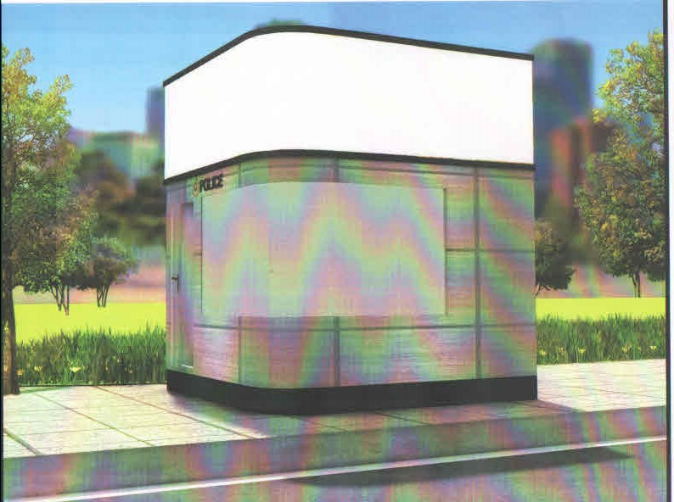

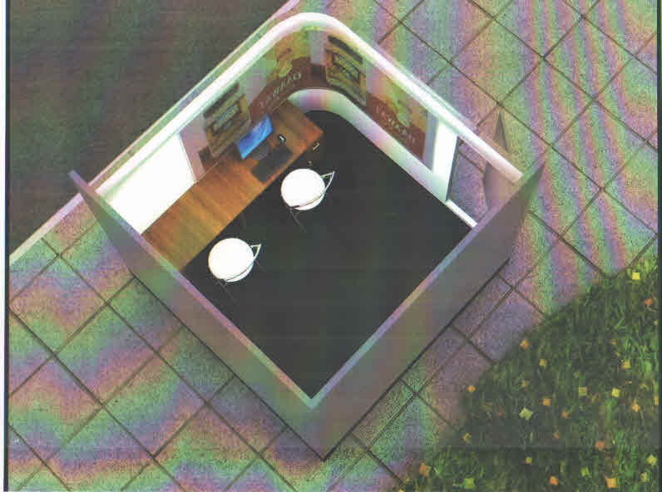

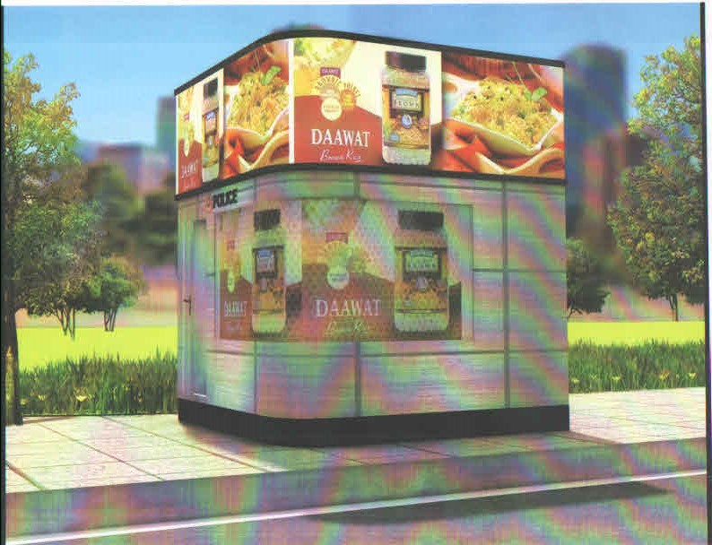

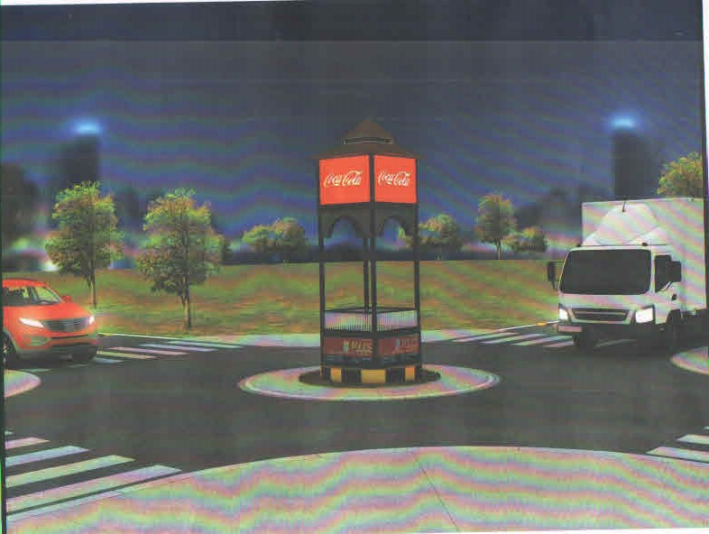

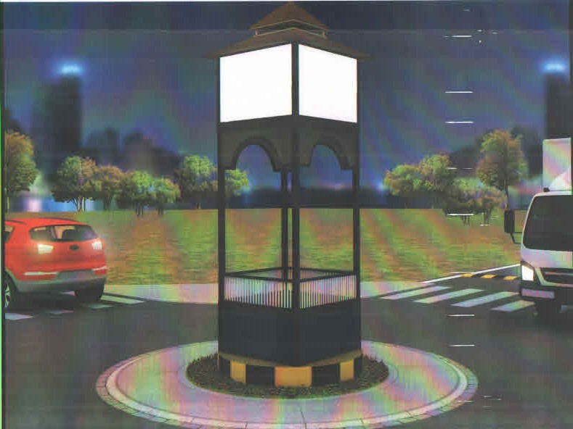

1.