Technical Specification & Design

The scope of work consists of:
- Introduction of modern underground waste system for secure garbage collection.
- Install 2 bin underground waste bin system for its effective operation.
- Eliminate open dumping thus, keep away stray animals feeding on waste.
- Design semi-mechanised system for minimal garbage handing.
- Design for improvement of existing transportation system.
- Activate awareness among the users for proper disposal of waste.
- Implement greenest and safest solution integrated with urban development.

Installation and Civil work required for underground Bin:
    - Pit excavation
    - Installation/unlading of precast concrete bunker
    - Soil filling and closing of the pit surroundings and installation of the container
    - Rebuilding of surroundings/pavement or as per the requirement of location.
    - The system is installed on any specified space i.e. pavements / walkways for easy access by the user
    - The bunkers are placed square to each other forming a waste collection container island
    - The system is designed with a watertight seal to secure any type of water leakage inside

Technological Overview:

Introduction of Underground bins as an efficient solution to address the solid waste storage, collection and transportation challenge at Dehradun:

The aim of underground container system is the collection of municipal solid waste. The garbage is collected in the hidden underground containers that comply with all the environmental, health, safety and corrosion standards. The Leak-proof concrete tanks are installed underground and polyethylene containers are used for collection of segregated or mixed municipal waste. The lids of the system are covered with matching paving material of the surrounding area and different type of steel input bins at ground level indicates the waste collection points, simply helps the local inhabitants fulfil their environmental obligations as regards to the disposal and segregation of household refuse.
Underground Containers are often used at suburban areas as well as at Residential Areas. These bins are made of precast concrete bunker having water proof, closed construction, top cover lid to be hydraulically fixed in water tight condition with necessary provision to lock the filling lid for secured garbage storage in MDPE/HDPE Container suitable for collecting municipal solid waste. This product is customised to be installed at city road or pavement to receive the solid waste by the user and also directly from tri-cycle (rickshaw)/ tri-cart engaged at municipal work.

Specification of 3 Cubic meter model is as follows:

Figure 1 | Figure 2

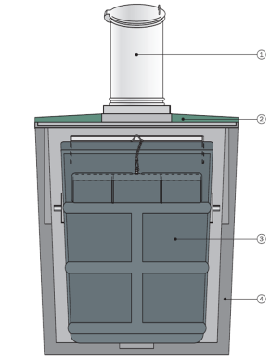 | - Item 1 proposed to be designed with double trap door/opening to receive the waste by the user and also directly from tri-cycle (rickshaw)/ tri-cart. The pictorial example has been display as follows:
  - One stainless steel intake column to accept the waste.
  - One lid with a lock for locking the raise including hinges, gas cylinders which are necessary to help the operator to raise and lower the lid.
  - One bottom open/close bottom bin/container to store the waste.
  - One concrete bunker to receive the bin/container.

The stainless steel intake column must be so designed to accept garbage collected in tri-cart and hard carts. The intake column to have 2 separate opening, frontal opening accept the garbage from end users, shops and nearby vendors while the opening at back receives garbage collected by municipal workers.

Size and Technical Details of 3 cubic meter underground bin:

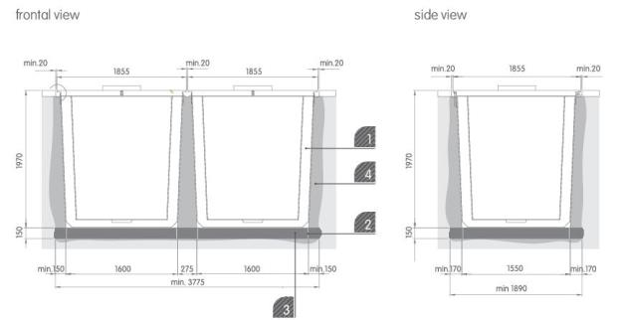

- Concrete Bunker
- Stakes
- Concrete Foundation
- Filling with soil and gravel

Underground Bin Technology, Design, architecture and concept:
The proposed underground waste collection system complies with all the environmental, health, safety and corrosion standard. Leak-proof concrete tanks with efficient drainage systems are installed underground and polyethylene containers are used for collection of segregated or mixed municipal waste. The lids of the system are covered with matching paving material of the surrounding area and different type of steel input bins at ground level indicates the waste collection points, simply helps the local inhabitants fulfil their environmental obligations as regards to the disposal and segregation of household refuse.

The specialised MDPE containers are designed to collect mixed and segregated waste. The bins allow collection of loose (un-bagged) waste especially Indian solid waste that contains 50-65% of biodegradable waste. The bins are designed to collect 70 – 180 litres of water/leachate commonly found in mixed Indian waste. The bins are made bang proof and are designed light weight that needs smaller crane, hence lower investment in collection equipment. To empty the proposed bins any refuse collection vehicle mounted with telescopic knuckle boom crane with foldable arms is needed. The propose bin has 2 different bin designs that can be adapted for fit in use RCV’s with the municipalities. The garbage is collected in bottom close container with a single hook grab system in the specialised compactor RCV’s while the bottom open container can be lifted and emptied with a double hook system grab and open fitment in the crane.

ToR:
- Bidders should be deposit 2% Ernest money as FDR in the favour of Account Officer, Nagar Nigam, Dehradun.
- The tender is valid for initialisation 1 unit Under Ground Dustbin to demonstration purpose at Nagar Nigam Office campus, Dehradun.
- Bidders ensure the quality of UGD.
- Bidder should not be black listed.
- Bidder working experience in the same field may give additional preference. The bidding firm should have experience of currying out at least 3 (three) years in the similar assignments.
- After the successful initialisation will processed the payment to bidders.
- No advance will be permitted for the demonstration unit.
- An agency will be selected in accordance with Q&CB selection method.
- Nagar Nigam Dehradun reserves the right to accept / reject tenders without assigning any reason thereof.

