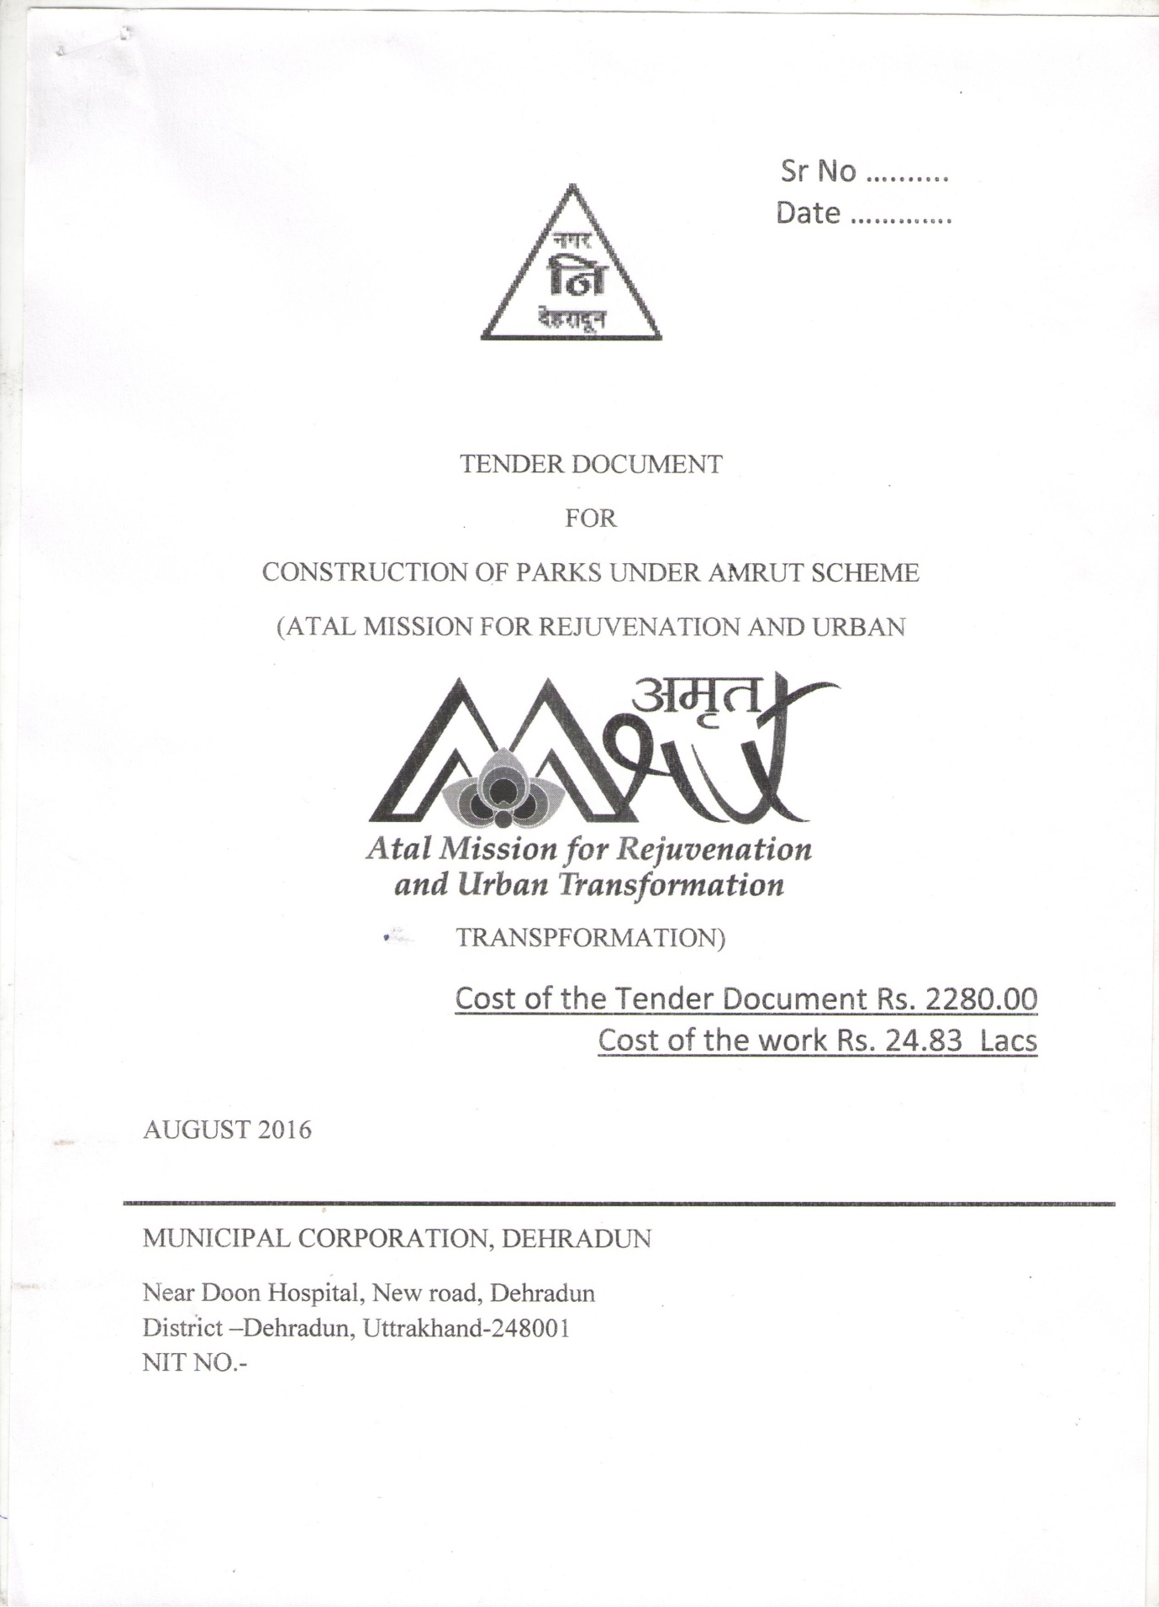

PARTICULARS OF THE TENDERS
 | Particular of the Work | - Construction of Lala Lajpat Rai park Indira nagar colony Dehradun Uttrakhand as urban green space
 | Period of construction | 3 month
 | Cost of Tender Form | Rs 2280 each
 | Earnest Money | Rs 50,000 each
 | Date& time for getting tender document | Till 08.12.16
 | Date & time of Submission of tender | 09.12.16
 | Date of Opening of Technical Bid | 09.12.16
 | Date of Opening of Financial Bid | To be Informed later
 | Place of Opening of Tender | Executive Engineer,  Nagar Nigam, Dehradun
 | Period of Validity of Tender | 3 months
 | Name and Address of the firm to whom tender document id issued | ……………………………………  …………………………………..

Executive Engineer
Nagar Nigam, Dehra Dun.

PRE QUALIFICATION, TECHNICAL BID AND FINANCIAL BID REQUIRMENTS
- Construction of Lala Lajpat Rai park Indira nagar colony Dehradun Uttrakhand as urban green space
The tenderer/bidder should give a detailed technical proposal and financial proposal for the above detailed work complete in all respect. The financial/commercial bid shall be opened only after approval of technical bid from the Nagar Nigam Dehradun.

All the bids shall be examined and evaluated first technically and as per the past experience of similar nature work, financial capability and others relevant factors related to similar type of project i.e. beautification work, construction of park, horticulture projects, buildings, etc. Details to be provided with the technical bid:-

Tenders/RFP are invited from the reputed, capable, efficient and experience firms/ organization/ PSU’s/ contractors registered in Central/State Govt departments/ undertakings to construct the above work in a limited time of six months of maintenance.
Pre requisite/ Pre qualification for the tender

1. Earnest Money of Rs. 50 thousand for each bid in the form of NSC/ FDR/ Bank Guarantee for 12 months extendable as and when required in the name ofS. F.O, Nagar Nigam, Dehradun.
2. If form is down loaded from the web site, cost of tender form of Rs. 2280.00 for tender document in the form of bank draft in the name of F.O, Nagar Nigam, Dehradun should be deposited with the tender form/bid.
3. Income tax registration with PAN card copy.
4. Sales/trade tax registration number
5. Labour department registration or any other statutory registration required.
6. Affidavit with the detail that the firm/ bidder have not been black listed from any government, semi government, organization due to default.
7. After the satisfaction of above conditions, further technical bid shall be considered.

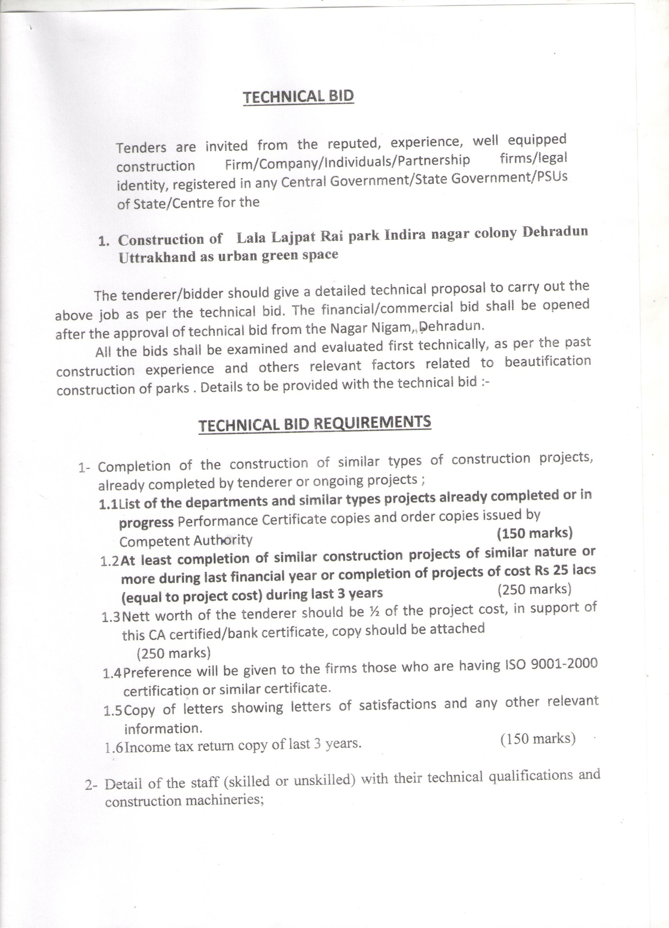

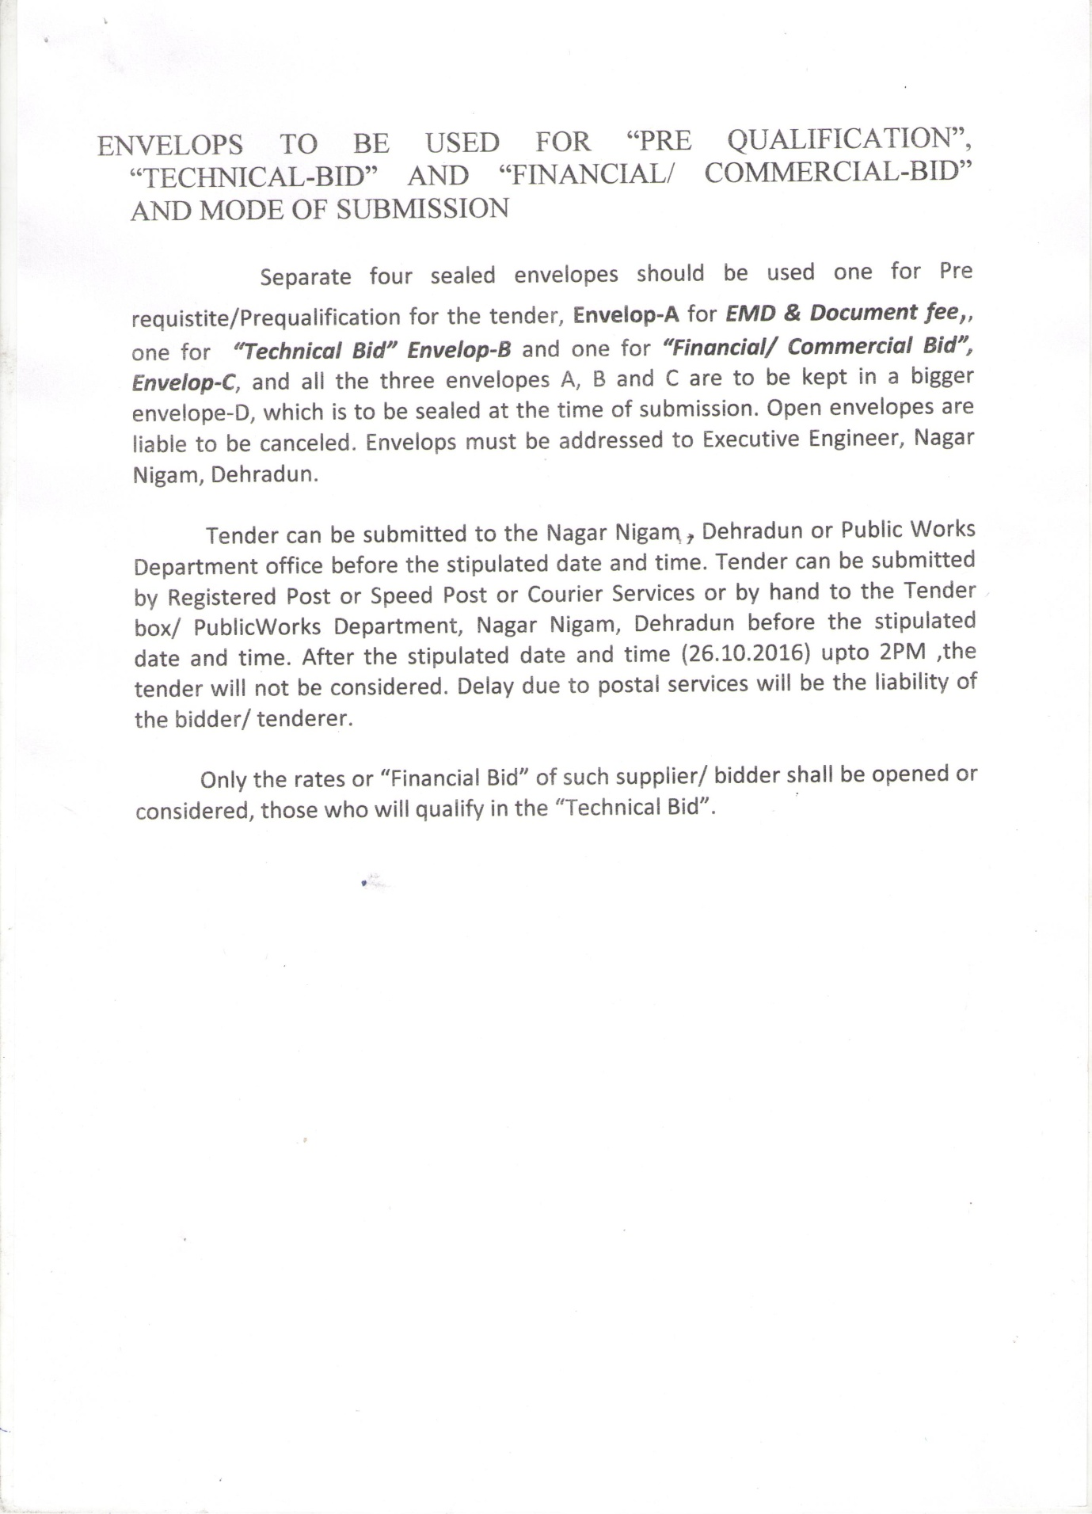

ENVELOPS TO BE USED FOR “PRE QUALIFICATION”, “TECHNICAL-BID” AND “FINANCIAL/ COMMERCIAL-BID” AND MODE OF SUBMISSION

Separate four sealed envelopes should be used one for Pre requistite/Prequalification for the tender, Envelop-A for EMD & Document fee,, one for “Technical Bid” Envelop-B and one for “Financial/ Commercial Bid”, Envelop-C, and all the three envelopes A, B and C are to be kept in a bigger envelope-D, which is to be sealed at the time of submission. Open envelopes are liable to be canceled. Envelops must be addressed to Executive Engineer, Nagar Nigam, Dehradun.

Tender can be submitted to the Nagar Nigam , Dehradun or Public Works Department office before the stipulated date and time. Tender can be submitted by Registered Post or Speed Post or Courier Services or by hand to the Tender box/ PublicWorks Department, Nagar Nigam, Dehradun before the stipulated date and time. After the stipulated date and time (09.12.2016) upto 2PM ,the tender will not be considered. Delay due to postal services will be the liability of the bidder/ tenderer.

Only the rates or “Financial Bid” of such supplier/ bidder shall be opened or considered, those who will qualify in the “Technical Bid”.

